ALVIN D. SIMS SCHOLARSHIP PROGRAM (ADS)

RE-APPLICATION
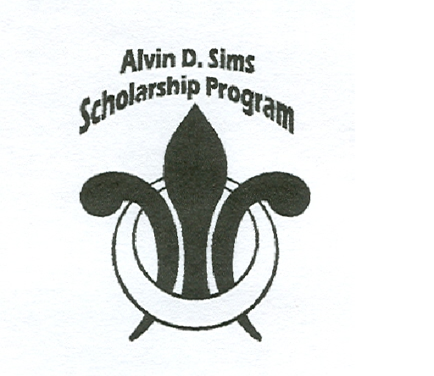
The Alvin D. Sims Scholarship program awards scholarships for PUBLIC SCHOOL STUDENTS who plan to attend or STUDENTS who currently attend PRIVATE or PAROCHIAL ELEMENTARY SCHOOLS (1ST-8TH Grade). ALL APPLICANTS MUST HAVE A FINANCIAL NEED (TO BE DETERMINED BY SCHOOL), AND STUDENT CANNOT ALREADY HAVE OTHER FINANCIAL ASSISTANCE!

_____ Returning Students _____New Students Added

Parent/Guardian Information
Bob Perkins
Sponsor

Jocquelline Kelly
Scholarship Coordinator
773.537.5221
AdsScholars.org
AdsScholarship@yahoo.com

Mailing Address:
P.O. Box 12406
Chicago, Illinois 60612

Office:
Notre Dame De Chicago parish
1335 W. Harrison Street
Chicago, Illinois 60607

Name___________________________________________________________

Address_____________________________________________ APT. #_______

City________________________State______________Zip________________

Home #________________Emergency #______________Cell #____________

Email Address: ___________________________________________________
PLEASE PRINT CLEARLY
THIS EMAIL WILL BE USED FOR ALL CORRESPONDENCES

Place of Business__________________________________________________

Business #___________________________ Annual Income_______________

If not working, source of income_______________________Family Size_____

Emergency Contact Information

Name______________________________________________________________

Relationship to Applicant_____________________ Phone ___________________

-Please Do Not Write Below This Line-

-For Alvin D. Sims Office Use Only-

(Please Print)

(Child) #1 Gender (M/F): __________
Name___________________________________________Date of Birth_____________
School Currently or Planning to attend_______________________________________
Address___________________ Zip________ Contact Person _____________________
School Tel#________________ School Fax#___________________________________
Years in program? ________________Grade New School Year (Sept.) ______________

(Child) #2 Gender (M/F): _________
Name___________________________________________Date of Birth_____________
School Currently or Planning to attend_______________________________________
Address___________________ Zip________ Contact Person _____________________
School Tel#________________ School Fax#___________________________________
Years in program? ________________Grade New School Year (Sept.) ______________

(Child) #3 Gender (M/F): _________
Name___________________________________________Date of Birth_____________
School Currently or Planning to attend_______________________________________
Address___________________ Zip________ Contact Person _____________________
School Tel#________________ School Fax#___________________________________
Years in program? ________________Grade New School Year (Sept.) ______________

(Child) #4 Gender (M/F): _________
Name___________________________________________Date of Birth_____________
School Currently or Planning to attend_______________________________________
Address___________________ Zip________ Contact Person _____________________
School Tel#________________ School Fax#___________________________________
Years in program? ________________Grade New School Year (Sept.) ______________

Page 2
Instructions for Parents/Guardians and Potential Recipients:
Please follow the directions below and answer ALL requested information. Your application WILL NOT be considered if any question is incomplete, inaccurate and/or if parents/guardians and child do not sign signature lines below. Only fill out one application per family.

Submit applications to Jocquelline Kelly, Scholarship Coordinator at: AdsScholarship@yahoo.com. Please ensure that you add an email address, all correspondences will be via email and website. You will be notified by email of the eligibility status.
Questions

- Please answer in detail why you would like your child to attend a Private, Christian, or Catholic School?

2. Do you agree to have your child’s grades submitted by the school and have a conference with Scholarship Coordinator after each marking period to discuss your child’s strengths/weaknesses? ____Yes ____No

3. Do you agree to spend quality time daily helping your child with his/her homework? ____Yes ____No

4. Do you agree to share any problems that seem to be hindering your child’s progress in school? ____Yes ____No

We the undersigned, agree to all of Alvin D. Sims Scholarship Programs eligibility guidelines upon acceptance of program.

________________________________________ __________________
Parent/Guardian Signature Date

________________________________________________ _____________________
Student Signature #1 Date

________________________________________________ _____________________
Student Signature #2 Date

________________________________________________ _____________________
Student Signature #3 Date

________________________________________________ _____________________
Student Signature #4 Date

________________________________________________ _____________________
Alvin D. Sims Scholarship Coordinator Signature Date

Page 3

